Project report: Event planning and scheduling app
Prepared by: Edwin Mouawad
Date: March 25.
Introduction:
In today’s fast paced environment, managing events is crucial for individuals and organizations. This project helps in simplifying event planning process. This app is developed to create events, create tasks, managing RSVP tracking and more.
Overview:
The app was designed to provide the user a user-friendly interface for planning, organizing, scheduling and managing events, add guests, create tasks, budgeting tool to track expenses, create templates, maintaining a data base, generating event report and exporting it and it comes with a calendar to escape confusions. I donwnloaded MailKit and Iptext.
Class User:
Line 15 21: variables to add the user name, password, email, age, verified(to see if the email entered by the user is real), a static List<User> (to save the users in a list), a static User to know which current user is logged in, a static List<Event> (to save events for a user in a list) (user1 cannot see user2s events ).
Line 25 34: Initialized a constructor with all the necessary requirements from above (username, password, email, age) this constructor was used for the sign up page. Also in this constructor we added isVerified = false, this means that when a user signs up, there email is not verified yet (this is changed in the confirmation code form). This.events = new List<Event> means that a user starts with no events. The load user events mean that events will be loaded for the right users.
Line 36 41: Another constructor. Initialized a constructor with username and password. This.events = new List<Event> means that a user starts with no events.
Line 43 46: The function LoadUserEvents loads the list of events for the current user.
Line 48 51: Returns the value of the private password so it can be used in log in and sign up.
Line 53 78: This a static sign up message to allow a new user to create an account using a username, password, email and his age. The foreach User u in users check if a username exists in the list. If it exists a user cannot create an account using this name. If the user did not fill a valid password, he cannot sign up, a password should contain Upper case letters, lower case letters, numbers and digits. If a user is under 18 he cannot create an account. The password is then hashed, and now that everything is valid a user can create an account and is added to the list of saved user the we save his account credentials to csv file.
Line 81 91: This is the logout function(static), filled with the username and password. Password is hashed, then the program loops from 0 to the number of users saved in the list<User> to see if the username and password matches an individual to allow logout. If a there is a match the user is removed from the list (RemoveAt index).
Line 93 97: This is function to return the info needed to be saved in a csv, makes the work easier.
Line 99 108: This is a static method that allows to save users in a csv file, using StreamWriter, we used the function above for user save at right place.
Line 110 131: static method to import users from a file. We used streamReader to load users from a csv file.
This is the login form: what was used here is a picture box for design, labels for design the text boxes for the user be able to enter the required fields, 2 link labels for design, a check box to see passwords, a button login to validate the user inputs and a panel containing a picture. In this form we verify the input of the user. Line 18 importing already existing users in the load. Line 23To see the password. Line 4246: when the link label is pressed it takes us to another form for sign up. Line 4853: reset everything to default. Line 57 insures that the user name entered is a fuctional name and not just 3 characteres, And makes sure that the password is a strong password. Line 91121: checks if the username, email and password where found so it allows the user to move to the next page or not. If the user inputs were found a notification pops out welcoming the user. Line 126 for the check box(to see the password).
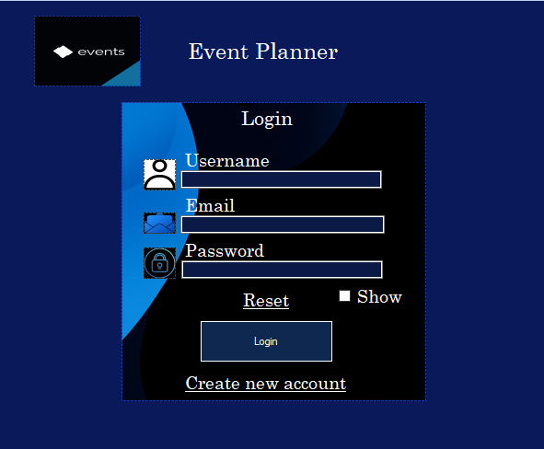
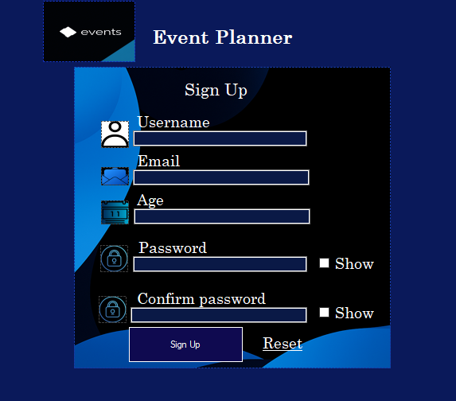
In this form, an email is sent to the user, this email contains the confirmation pass to check if the entered email is a real email or not. In this form there is a picture box for design, labels for indication, a textbox, a panel and a button. Line 17-19: initialized the string email, the code, and the confcode(each has its own use). The constructor here take email as a parameter (the email is that of the entered email in the signup page). Line 31-67: I used stmp and mailkit to be able to send the confirmation pass. I used try catch to avoid any possible error (ivalid email…). I was able to write this code from a youtube video, althought it was really old and had to loads of modifications… this took me more than week to make it work. Line 70: the email is sent on load. Line 75-93: This button confirms that the entered code is that of the one sent over the email. A user cannot enter an empty code and if the code was not valid the user stays in this page until he enters the write code. Dialog result ensures that the pass was correct and know we can go to the login form. And at the end a notification pops up.
This is the sign up form: what was used here is a picture box for design, labels for design the text boxes for the user be able to create an account, link labels for design, 2 check boxes to see passwords, a button login to validate the user inputs and a panel containing a picture. In this form the user can create an account. Line 32108: Check if the user entered all fields with the required conditions, (password contains the necessary requirements, checks if the confirm pass is = to the actual pass, username length>, age is between 18 and 99, checks if the username does not exists in the csv, same to the email). Line 110-110 moves us to the confirm pass form.
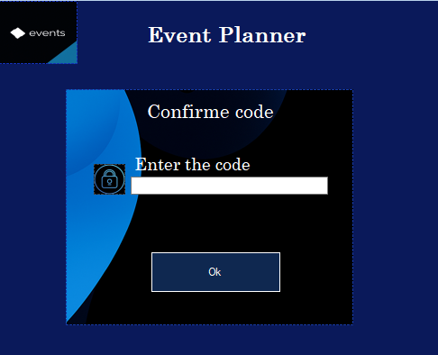
Line 103 105: This button allows the user to go back the sign up form.
Now back to the sign up page Line 113 131: I used dialog result to let this form know that the input was valid in the other form so now the user is able to login normally (a notification also pops out) We also used the sign up method from the user class. Line 137-139: on the load, Users are imported. And the next part is for the 2 check boxes. Line 153-169: Resets everything.
Class Event:
Line 12: public string property to store event name.
Line 13: public string property to store event type.
Line 14: public string property to store event location.
Line 15: public DateTime property to store event date.
Line 16: public string property to store event time.
Line 17: public string property to store user’s username.
Line 19 21: Empty constructor.
Line 24 32: This constructor takes string eventname , string eventtype, string eventLocation, DateTime dt , string time and string username as parameters.
Line 34 44: A virtual void string method to display event details.(virtual because this function will be modified later in the Task class).
Line 46 50: A method that returns a string of all the parameters in the constructor for easier use in other methods.
Line 52 59: This is a static method that returns Event as an output to divide the string into parts for easier use later.
Line 61-72: events are saved into a csv named Events_{username}.csv so now each event foreach user is saved in the in a file after the username (which can’t be repeated).
Line 74105: returns a list of already saved events using stream reader.
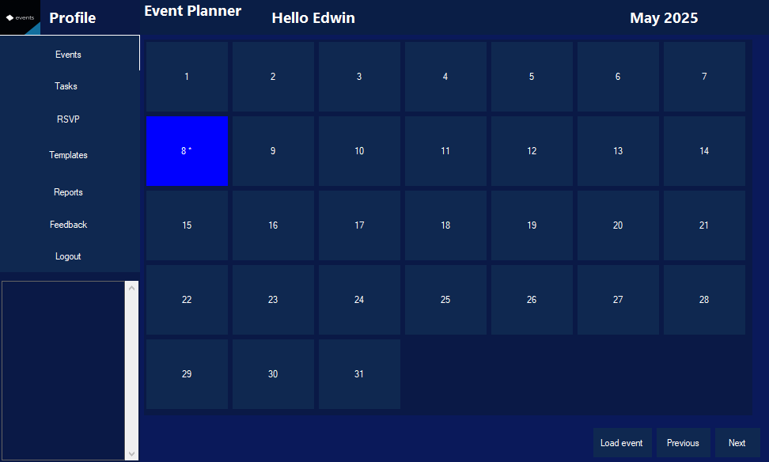
This page is accessed if the a user is already created. In this page we find a lot of buttons in a flow layout panel; these buttons helped me do the calendar (took me 6 days to figure it out). We find labels for indication and designs, buttons in a panel to move between forms, buttons to see the next month or previous month, a button load to load events into a textbox and finally a picture box to move the side bar.
Line 1932: Created a list of event, task, rsvp tracking, string username, password, DateTime date, int month, year and propirties for the side bar.(explanation later).
Line 3346: The form constructor takes username (for naming csv according to users), password(to use the logout function from the user class). A notification pops up when the form is called. The saved events are loaded into the list events using line 44 and the load user event from the Event class.
Line 4952: was a failed attempt to send notification.
Line 6272: used to move to the add event page.
Line 7378: used for the side bar design (update its width).
Line 80104: this is the code to do the sidebar animation.(this code was inspired by a youtube video). The code start by decreasing the width of the sidebar. then stops at min width set for the sidebar, timer stops and we use the updateWidth function. The rest is the reverse except that the timer is also stoped. Line 115: the timer of the animation start.
Line 106147: are used to move between forms (this.close is better the .hide).
Line 153202: this function is used to set the calender view. Variable month, year to know what month and year we cuurently are in. foraech control refers to everything in the flow layout panel.
Line 203229: events are loaded into a list. If the username name matchs the currently logged user, the date, year the event is displayed in a textbox. Else no event is loaded.
Line 231251: allows the user to next month events or the previous months events by incrementing (or reverse) the month by one until we reach a condition which is that of the month December (12) then we know we have to move a year.
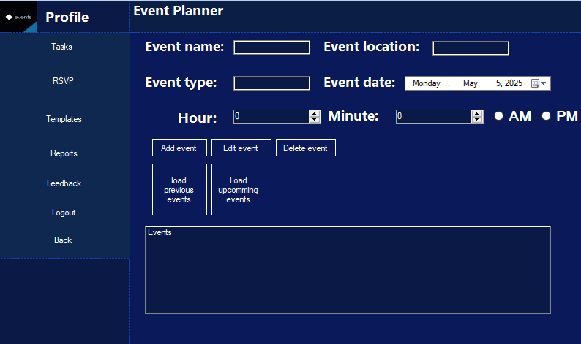
Line 2743: the constructor takes 3 arguments. user events are loaded into a list. And the rest is a failed attempt for the date time picker have the same value of the pressed date from the calendar.
This is the event page, the user can create an event, edit it, delete it, load previous event and current events. We used here text boxes, datetimepicker, numericisupdown and a list box,
Line 4558: Update the list box, update the sidebar panels width.
Line 6099: events are loaded into a list. Line 6586: failed attempt for remeinders but worked as a normal notification. Rest of the line here are to set the default parameters when loading the form. Line 101170: set the location of the of everything in the form while the side bar animation is happening.
Line 181234: make sure a user fills all the required fields. A user cannot create an event in the past, the radio btn cannot be true at the same time, and the time entered by the user is converted to a visualy appealing to the user. Then the event is added to the list, Events are saved into the proper csv. Then all the fields are cleared, then the refreshed the list.
Line 250273: the events are loaded into the lsit from the csv. If no event is created no events appear on the list.
Line 275308: if the events are loaded in a list, what is saved to that list is the umpcomming events. In the second function only previous events appear on the List.
Line 310331: this btn allows the user to delete an event completely from the csv and from the list. We search the index of the selected event and remove it then update the list, an events cannot be deleted without being selected from the list box.
Line 335399: the user needs to select an event, fill all the necessary fields then the new edited event is saved in place of the other one(previous event).
Line 443: past events are loaded.
Class Task:
This class inherits the event class. The goal was from this is that every event has its own tasks. I created two constructor, on has one more parameter and its that of the budget.
Line 3558: the are function to make it easier for the csv.
Line 6168: display the tasks. Line 6979: used stream writer to save tasks into csv. They are saved into a file name tasks_username_csv. The username varies depending on the logged user. Line 81102: load tasks for the username and for a specefique event using streamreader.
Class Budget:
Set the budget and the total expenses. And a Dictionary<string, double> used to select the task name to be able to add an expense to it.
Line 2244: allows the user to add expenses, set budget, and see the remaining budget.
In this form there are 2 list boxes, one form the saved events, one to see tasks, lots of btn to add a task, edit it, delete it, a btn to add budget, text boxes to add the necessary fields.
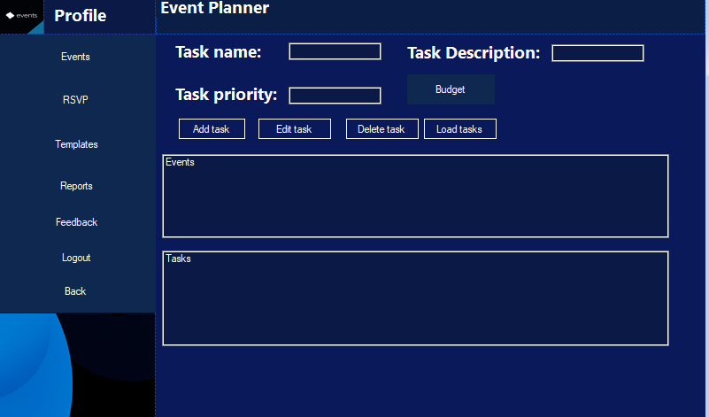
initialized these: private List<Event> userevent = new List<Event>();
private List<Tasks> currentTask = new List<Tasks>();
private List<RsvpTracking> rsvpTrackings = new List<RsvpTracking>();
private string username;
private string password;
private DateTime dateTime;

private Event selectedEvent = null;
Budget userb = new Budget();

private bool sidebarexpend = true;
private static int Sidebarmaxw = 179;
private static int sidebarminw = 53;
private static int sidebarstep = 10;
the constructor takes into account 2 parameters used for the logout. Events are loaded at the start (when the form is loaded).
Line 4373: The user cannot add a task before selecting an event. He also needs to fill the necessary fields. If everything is valid the tasks are saved to the correct csv and displayed in the list.
Line 149159: when an event is selected from the list box the event name appears in a label.
Line 161198: a user needs to select an event and a task to edit. Then refill the necessary fields then the changes are saved into a csv file in place of the edited event.
Line 200217: the user needs to select an event and a task to delete an event. Then the index of the selected task is removed from the list and from the csv.
Line 218249: load tasks for selected events. If a budget is added, it is displayed in the list, else budget appears = 0.
Line 251-261: tasks are loaded.
Line 314341: the user needs to select a task,then is sent to the budget form where he will be able to set a budget, reselect a task(just to make sure) add expected expensise. Then exists. If everything is valid from the class budget the user returns to the task class.
RSVPtracking class:
This class also inherits the event class. Same functions are reused in this class from the task class except with different name and with the right fields.
Methods class:
Line 1224: hash the a string.
Line 25 30: generate a confirmation code.
Line 3762: pass verification, email verification, phone number verification.
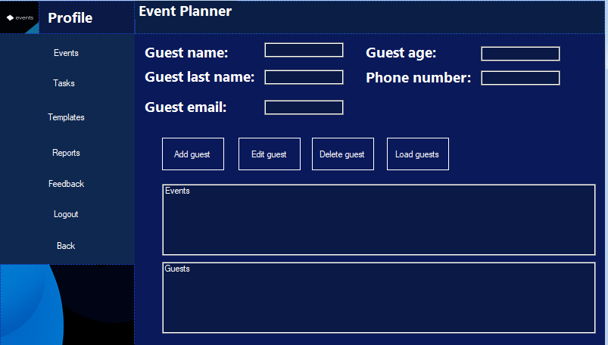
Same thing as the other form.
The difference here is the that there are more textboxes and the user need to select events before adding, editing, loading and deleting a guest. There are functions called from the methods class so that a valid form of an email and a phone number are added.
Class Template:
This class also inherits events and has exatly the same parameters as its mother class.
Templates are saved to a list. The display is the same as that of the event class.
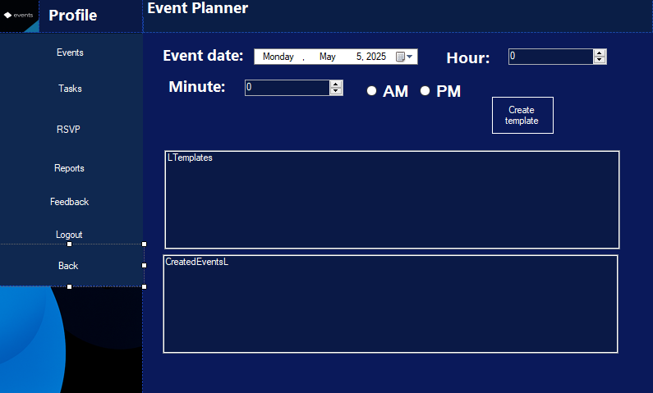
In this form everything is similar to the event form, except that the user does not have to enter the event name, type and location. He only needs to add a date and time. When btnCT is pressed, the event is added to the list of events (also in the csv) and is displayed in the list box.
Generatereport class:
Line 1299: the report generated must be starts with the event details, then the guests, then the tasks. (if there are no guests or tasks added the report outputs no event added).
And then they are saved into a file.
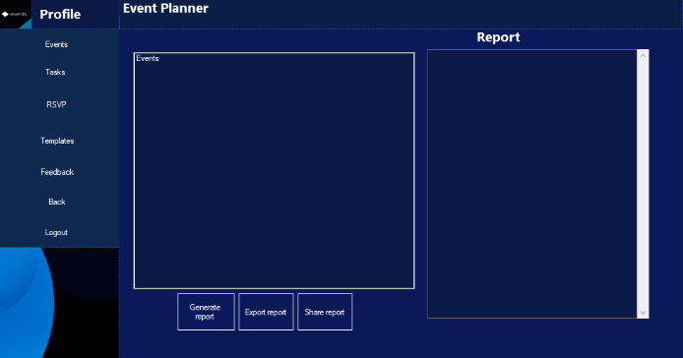
In this class the events appear on the list events, then when btn generate budget is pressed the output of the previous class appears on the list box. When exporting details the user can choose a file to export the generated report into a pdf. There is a friend that helped do this and without him it would have been impossible. There is a failed attempt to allow user to be mailed with the pdf.
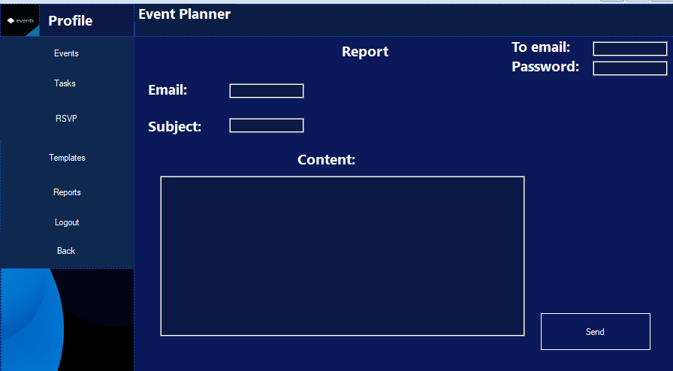
This class allows the user to send feedback to me, to say they theyre opinion about the app.
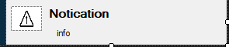
This form just pops messages about certain info needed. Learned a way to use it from youtube and changed it my way at the end.

Conclusion:
The project could have been better, I could have done better. But I am happy with the final output, because I really did more than I imagined to do. I am also happy that I did not need to rely on an ai to do the code, but there was stuff I could not have fixed with ai, but happy because the app looks good, I got better at a lot of stuff, discovered a lot of stuff and I definitely am really tired. The project help user to manage there events more efficiently, theyre tasks, guests,creating templates, adding budget, sending feedback, generating/ exporting reports, having a calendar view and maintaining a good data base (which took the most part of the project (possibly more than 2 weeks)) and a backup option(everything saved to csv).

